

Lab Report on

Basic C,loop,function,array,string,file

**Course Title:** Structured Programming Language Lab

**Course Code:** CSE 112

**Date of Submission: 13.01.19**

**Submitted by:**

**Name :** Syeda Nowshin Ibnat

**ID :** 17183103020

**Intake :** 39

**Section :** 01

**Program :** B.Sc. in CSE

**Submitted to:**

**Name:** Md. Hasibur Rahman

Lecturer,Dept. of CSE at

Bangladesh University of Business and Technology.

Lab -2(basic C and nested if, else)

Objective:♦ To be familiar with different data types, Operators ,Expressions and nested if, else in C.

**Prog-1**

**Title:** Print a character twice in the same line.

**Source Code:**

#include<stdio.h>

int main()

{

char A;

printf("Enter any character:");

scanf("%c %c",&A,&A);

printf("ch=%c %c",A,A);

return 0;

}

**Output:**

character twice in the same line.

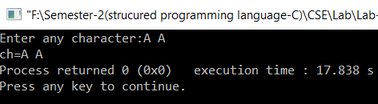

**Prog-2**

**Title:** Find the greatest number among three numbers. Program also evaluate whether two number among them equal or not.

**Source code:**

#include<stdio.h>

int main()

{

int a,b,c;

printf("\nEnter three integer number:");

scanf("%d %d %d",&a,&b,&c);

if((a>=b)&&(a>=c))

printf("a is the greatest one");

else if ((b>=a)&&(b>=c))

printf("b is the greatest one");

else if((c>=a)&&(c>=b))

printf("c is the greatest one");

if(a==b)

printf("\na and b are equal");

else if(b==c)

printf("\nb and c are equal");

else if(c==a)

printf("\nc and a are equal");

else

printf("\nthey are not equal");

return 0;

}

**Output:**

The greatest number among three numbers and check them equal or not.

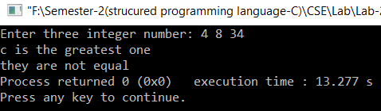

**Prog-3**

**Title:** Leap year Evaluation.

**Source Code:**

#include <stdio.h>

int main(){

int year;

printf("Enter a year :");

scanf("%d", &year);

if ( year%400 == 0)

printf("%d is a leap year.\n", year);

else if ( year%100 == 0)

printf("%d is not a leap year.\n", year);

else if ( year%4 == 0 )

printf("%d is a leap year.\n", year);

else

printf("%d is not a leap year.\n", year);

return 0;}

**Output:**

Leap year Evaluation

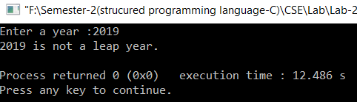

**Prog-4**

**Title:** Find maximum number among 5 numbers.

**Source Code:**

#include<stdio.h>

int main()

{

int a,b,c,d,e,max;

scanf("%d %d %d %d %d",&a,&b,&c,&d,&e);

if(a<b)

max=b;

else if(b<c)

max=c;

else if(c<d)

max=d;

else if(d<e)

max=e;

else

max=a;

printf("Max number is:%d",max);

return 0;

}

**Output:**

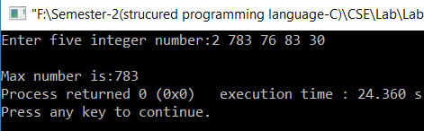

Lab -3,4,5(Loop)

Objective:♦ To understand the programming using Loop & nested loop Statements.

**Prog-1**

**Title:** A C program to find Reverse of a given number.

**Source Code:**

#include <stdio.h>

#include <stdlib.h>

int main()

{

int reversed=0,n,reminder=0;

printf("Enter the number:");

scanf("%d",&n);

while(n!=0){

reminder=n%10;

reversed=(reversed*10)+reminder;

n=n/10;}

printf("reversed number:%d",reversed);

return 0;

}

**Output:**

Reverse of a given number.

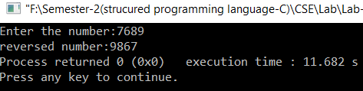

**Prog-2**

**Title:** Summation of prime numbers in a given range.

**Source Code:**

#include <stdio.h>

int main()

{

int num,i,j,flag,count=0;

printf("Enter an positive integer numbers:");

scanf("%d",&num);

for(i=2; i<=num; i++) {

flag=1;

for(j=2; j<=i/2; j++)

if(i%j==0) {

flag=0;

break; }

if(flag==1) {

count+=i; } }

printf("sum=%d",count);

return 0;

**Output:**

Summation of prime numbers in a given range.

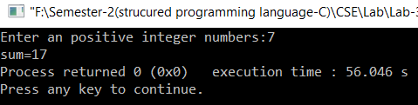

**Prog-3**

**Title:** Pattern printing of star triangle.

**Source Code:**

#include<stdio.h>

int main() {

int i,j,n;

printf("Enter a number:");

scanf("%d",&n);

for(i=1;i<=n;i++) {

for(j=1;j<=i;j++) {

printf("*"); }

printf("\n"); }

return 0; }

**Output:**

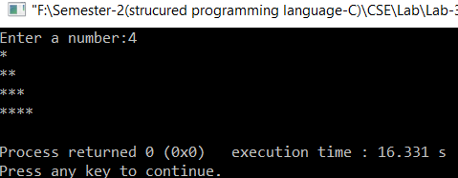

**Prog-4**

**Title:** Pattern printing of number pyramid.

**Source Code:**

#include<stdio.h>

int main()

{

int i,j,n;

printf("Enter number of rows:");

scanf("%d",&n);

for(i=1;i<=n;i++) {

for(j=1;j<=n-i;j++)

printf(" ");

for(j=1;j<=i;j++)

printf("%d",j);

printf("\n");

}

return 0;

}

**output:**

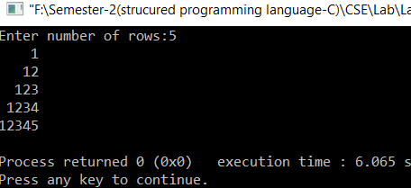

**Prog-5**

**Title:** A C program for Fibonacci series generation.

**Source Code:**

#include <stdio.h>

int main()

{

int i,n,a=0,b=1,temp=0;

printf("Enter the number of terms:");

scanf("%d",&n);

for (i=0;i<=n;i++)

{

i=a;

printf("%d ",a);

temp=a+b;

a=b;

b=temp; }

return 0;

}

**Output:**

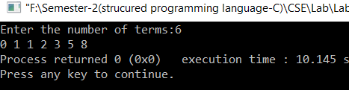

**Prog-6**

**Title:** A Pattern printing c program.

**Source Code:**

#include<stdio.h>

int main()

{

int i,j;

for(i=1;i<=5;i++) {

for(j=1;j<=5;j++)

if(i==3)

printf("0 ");

else

printf("* ");

printf("\n"); }

return 0;

}

**Output:**

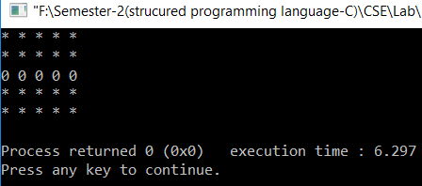

**Prog-7**

**Title:** Leap year print from 1901 to 2019.

**Source Code:**

#include<stdio.h>

int main() {

int i,a,b;//here, a=1901 & b=2019

printf("Enter lower limit:");

scanf("%d",&a);

printf("Enter upper limit:");

scanf("%d",&b);

printf("\nLeap year are:");

for(i=a; i<=b; i++)

{

if(i%4==0||i%400==0)

printf("\n%d ",i );

}

return 0;

}

**Output:**

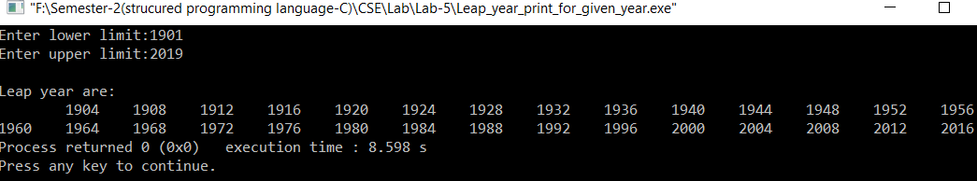

**Prog-8**

**Title:** Summation of palindrome numbers in a given range.

**Source Code:**

#include<stdio.h>

int main() {

int i,a,b,reverse,remainder,sum,result;//here,a=121 & b=1001

printf("Enter lower limit:");

scanf("%d",&a);

printf("Enter upper limit:");

scanf("%d",&b);

for(i=a; i<=b; i++) {

reverse=0;

sum=0;

result=i;

for(; result!=0; ) {

remainder=result%10;

reverse=reverse*10+remainder;

result=result/10; }

if(i==reverse)

printf("%d\n",i);

sum=reverse+sum; }

return 0;}

**Output:**

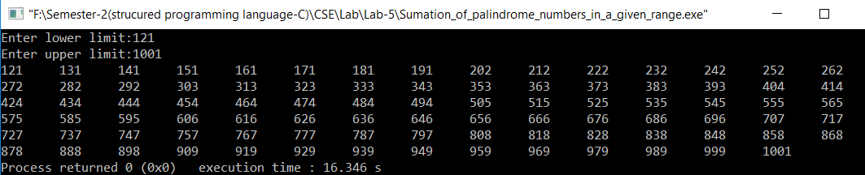

**Prog-9**

**Title:** A C program to Print Fibonacci number in a given range.

**Source Code:**

#include<stdio.h>

int main() {

int i,a=0,b=1,temp,X,Y;

printf("Enter lower limit:");

scanf("%d",&X);

printf("\nEnter upper limit:");

scanf("%d",&Y);

printf("Fibonacci Numbers Are:");

for(i=0;i<=Y;i++) {

if(a>X)

printf("\n%d",a);

temp=a+b;

a=b;

b=temp; }

return 0; }

**Output:**

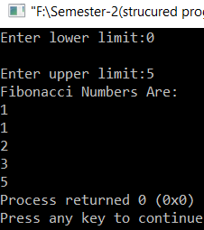

Lab-6 (Function)

Objective :♦ To understand function programming, its types and function-call.

**Prog-1**

**Title:** Summation of two numbers using function.

**Source Code:**

#include<stdio.h>

int main() {

int num1, num2, res;

printf("\nEnter two numbers : ");

scanf("%d %d", &num1, &num2);

res = sum(num1, num2);

printf("Summation of two number:%d",res);

return (0);

}

int sum(int num1, int num2) {

int num3;

num3 = num1 + num2;

return (num3);

}

**Output:**

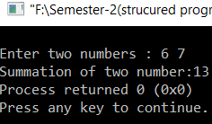

**Prog-2**

**Title:** Take float number and find the maximum number.

**Source Code:**

#include<stdio.h>

float Max(float a,float b,float c) {

float Max=0;

if(a>b&&a>c)

Max=a;

else if(b>a&&b>c)

Max=b;

else

Max=c;

return Max; }

int main() {

float a,b,c,d;

printf("Enter three numbers:");

scanf("%f %f %f",&a,&b,&c);

d=Max(a,b,c);

printf("The Max number is:%.2f",d);

getch();

return 0;

}

**Output:**

Lab-9(File handling in C)

**Prog-1**

**Title:** A program to open a file for reading.

**Source Code:**

#include<stdio.h>

int main()

{

FILE *fptr;

int num1;

fptr=fopen("file.txt","r");

if(fptr==NULL)

printf("File is missing");

else

{

fscanf(fptr,"%d",&num1);

printf("%d",num1);

}

return 0;

}

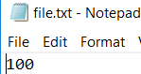

**Output:**

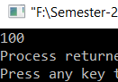

**Prog-2**

**Title:** A program to open a file for writing two numbers.

**Source Code:**

#include<stdio.h>

int main()

{

FILE *fptr;

fptr=fopen("file3.txt","w");

int num1=10043,num2=20091;

fprintf(fptr,"%d %d",num1,num2);

printf("%d \n%d",num1,num2);

return 0;

}

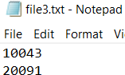

**Output:**

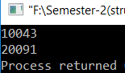



Assignment on

Vector Calculus

**Course Title:** Coordinate Geometry and Vector Calculus

**Course Code:** MAT 111

**Date of Submission: 13.01.19**

**Submitted by:**

**Name :** Syeda Nowshin Ibnat

**ID :** 17183103020

**Intake :** 39

**Section :** 01

**Program :** B.Sc. in CSE

**Submitted to:**

**Name:** Md. Abdul Hye

Assistant Professor of Mathematics at Bangladesh University of Business and Technology.